MEMBERS PRESENT: MAYOR DENNIS K LEAHY, DEPUTY MAYOR JAMES R BARNETT, TRUSTEE KEVIN GREANY, TRUSTEE DARYL CAPOZZOLI, TRUSTEE CHARLES D WOZNICK
ALSO PRESENT: ENGINEER SEAN HOFFMAN, POLICE CHIEF ARNOLD AMTHOR, DPW SUPERINTENDENT MATTHEW THORP, CLERK-TREASURER VALENTINA JOHNSON
PUBLIC: DEACON EDWARD GROSSO, BARBARA GROSSO, STEPHANIE GROSSO, CARLA GROSSO, CONNIE DESANTIS, DENISE JOHNSON, JOE & MARIE RAITI, MARIE BARNETT, NOREEN REYNOLDS, DONNA BARLETTA, EDWARD WILLIAMS, MARY STARRO, KARIN APREA & HUSBAND, LAURIE & GORDON THEW, JOHN LOWN, ANNA O’DONNELL
Mayor opened the meeting with the Pledge of Allegiance.
Mayor welcomed all to tonight’s meeting.
APPROVAL OF MINUTES
Motion by Trustee Barnett, seconded by Trustee Greany, approving the minutes of the November 30,
2022 meeting as presented. 5 ayes, 0 nays.
APPROVAL OF BILLS & CLAIMS
Motion by Trustee Capozzoli, seconded by Trustee Woznick, approving the following bills and claims as
audited by the Board of Trustees:
TRANSFER OF FUNDS
Motion by Trustee Greany, seconded by Trustee Barnett, authorizing the following transfer of funds to
cover deficit lines in the budget as requested by Clerk-Treasurer:
From: 3120.440A, Crime Prevention
To: 3120.400A, Police Contractual
Amt.: $600
From: 8320.400F- Source of Supply Pumping Contract
To: 8340.400F- Trans/Distrib- Contractual
Amt.: $5,000
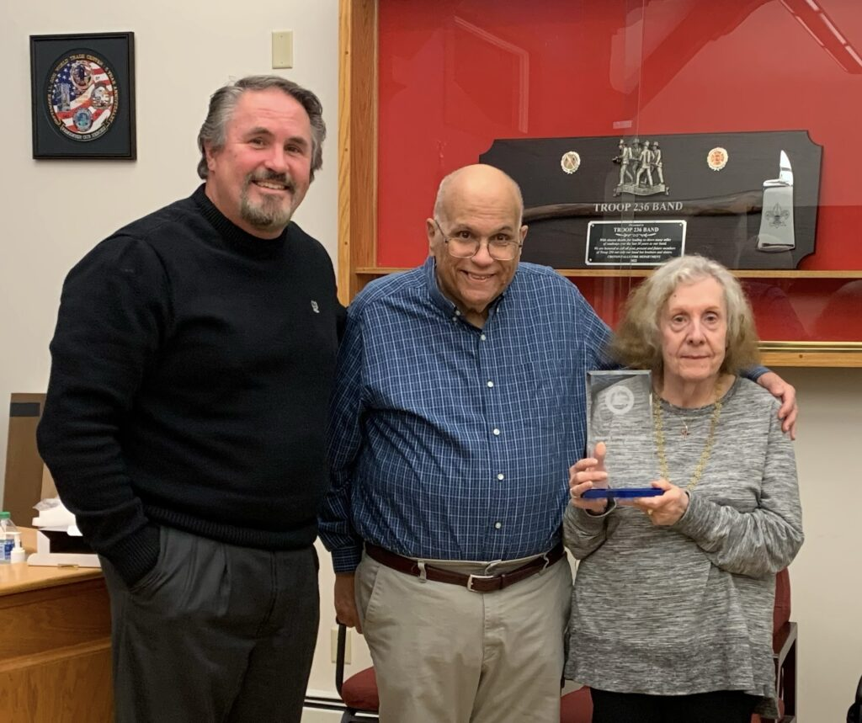
2022 JOSEPH E DINEEN AWARD
Every year since the Joseph E. Dineen Award was started in 2005, the Village of Maybrook Board of Trustees has selected a resident in the village who goes above and beyond as a volunteer. There were several candidates to choose from this year and unfortunately the Village Board is faced with the difficult decision of narrowing it down to one. This year is unique in that the Village Board of Trustees decided it was fitting to make this a co-recipient award. This year’s recipients are husband and wife. They established their roots in the Village of Maybrook in 1974. He was ordained a permanent Deacon in 1993 and was assigned to the Church of the Assumption Parish. He was involved with the Religious Education Program from 1975 until the 2015 merger of the Church of the Assumption with the Holy Name of Mary Church in the Village of Montgomery. He retired as an active Deacon this past August of 2022. His lovely wife began teaching Religious Education in 1975 as well. She is a catechist and held the position of Director of Religious Education up until the merger of the Church of the Assumption and the Holy Name of Mary. Now, I mentioned previously how they “Established their roots in the Village of Maybrook”. It’s one thing to move into a community but these two individuals did more than just establish their roots, they put their heart and soul into the Religious Education Program of the Church of the Assumption and made a tremendous impact in the development of children in our village. I know this from a personal perspective because my children, Sean, Alyssa and Dylan attended and received their sacraments through the Religious Education Program at the Church of the Assumption. This husband-and-wife team mentored many through the Religious Education Program at the Church of The Assumption and it’s only fitting to bestow this award onto them in appreciation for their 40 plus years of service. It is my honor to announce and present the 2022 Joseph E. Dineen Award to Deacon Edward Grosso and his lovely wife Barbara Grosso.
– Mayor Dennis K. Leahy

Deacon Ed advised it is an honor and thanked everyone. Barbara Grosso said thank you, Maybrook is an incredible beautiful place to live and she thanks God and thanks us for being able for them to serve us.
Joseph Raiti advised the Village of Maybrook has always been very accommodating and helpful, many places don’t do that, he thanks us for the fine job we do and continue to do.
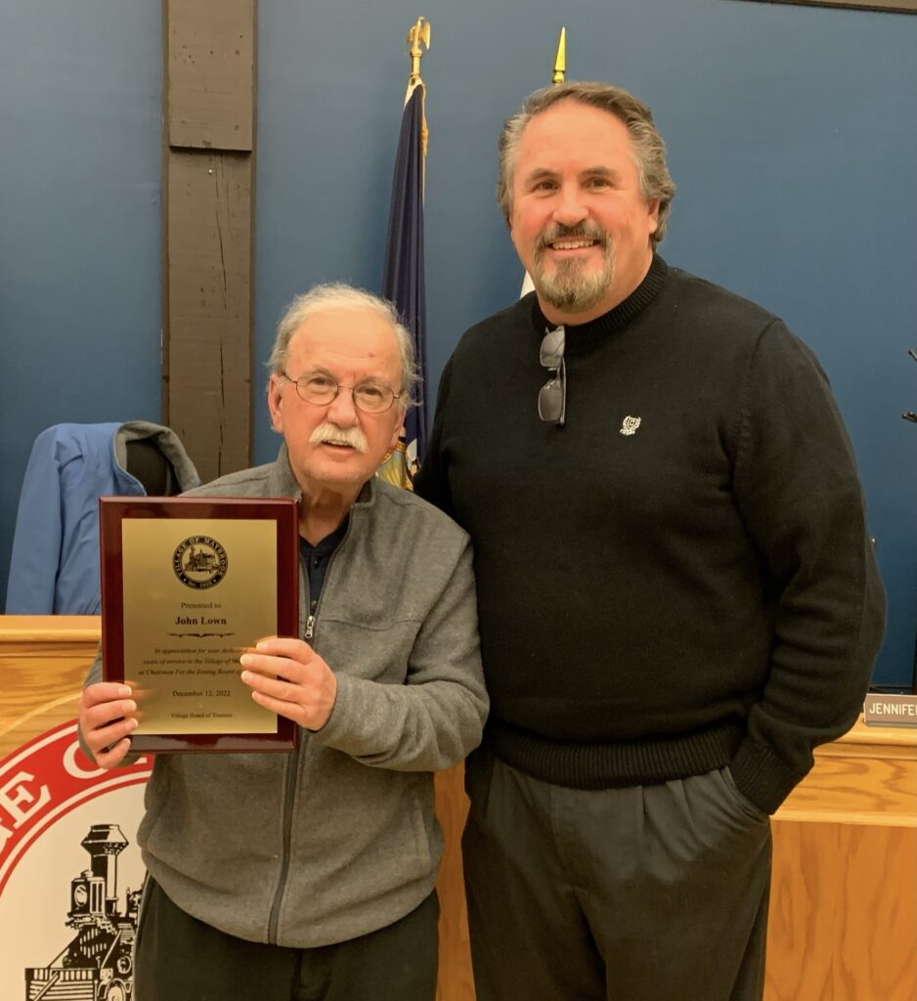On Monday, December 12th, Village of Maybrook Zoning Board of Appeals (ZBA) Chairman John Lown was presented an “Appreciation Award” for his service on the Village of Maybrook Zoning Board of Appeals.
Chairman John Lown announced his retirement at the end of this year and we appreciate the outstanding job he did during his tenure on the ZBA.
On behalf of the Village of Maybrook Board of Trustees, we wish him all the best and thank him for his service to the Village of Maybrook!
–Mayor Dennis K Leahy

PUBLIC HEARING
INTRODUCTORY LOCAL LAW #5 OF 2022 AMENDING CHAPTER 99, ENTITLED “FIRE PREVENTION AND BUILDING CONSTRUCTION” TO PROVIDE FOR THE ADMINISTRATION AND ENFORCEMENT OF THE 2022 AMENDMENT TO THE NYS UNIFORM FIRE PREVENTION AND BUILDING CODE
Motion by Trustee Capozzoli, seconded by Trustee Woznick, to open the Public Hearing at 7:15PM. 5 ayes, 0 nays.
Engineer advised on local law #5 and it is required to be adopted by the end of the year.
Motion by Trustee Barnett, seconded by Trustee Capozzoli, to close the Public Hearing at 7:17PM. 5 ayes, o nays.
Motion by Trustee Barnett, seconded by Trustee Greany, to adopt Local Law #5 of 2022. 5 ayes, 0 nays.
CORRESPONDENCE
- APPOINTMENT, KARIN APREA- P/T CLERK- Deputy Mayor advised he has no doubt that Karin will do well, we lucked out finding her. Motion by Trustee Barnett, with good fortune, seconded by Trustee Greany to appoint Karin Aprea as part time Clerk, effective immediately, at a rate of $18 per hour. 5 ayes, 0 nays.
- BUILDING INSPECTOR’S REPORTS- OCTOBER & NOVEMBER 2022- Deputy Mayor advised Tim has been very busy and also put a lot of input into the local law we just adopted. Rec. & filed.
- SET PUBLIC HEARING- ADJUSTMENT OF WATER RATES- 01-09-23- Mayor advised the Board has been in discussion, met in a work session and we are looking to increase the water rate by .10per one thousand gallons. Motion by Trustee Greany, seconded by Trustee Barnett, to set a Public Hearing on January 9, 2023 at 7PM. 5 ayes, 0 nays.
- AUTHORIZATION, GALAXY PEDESTRIAN EASEMENT- Engineer advised this is a big step and he is happy to bring this to you! Mayor thanked Sean & Kelly for all their meetings and moving this project along. Motion by Trustee Woznick, seconded by Trustee Capozzoli, authorizing Mayor to sign Galaxy Pedestrian Easement agreement. 5 ayes, 0 nays.
- AUTHORIZATION, 2023 VILLAGE BOARD MEETINGS- Motion by Trustee Barnett, seconded by Trustee Greany, approving the 2023 Village Board Meetings for 2023 as presented. 5 ayes, 0 nays.
- AUTHORIZATION, 2023 HOLIDAY SCHEDULE- Motion by Trustee Barnett, seconded by Trustee Greany, approving the 2023 Holiday Schedule as presented. 5 ayes, 0 nays.
- SET PUBLIC HEARING- RESTORE NY APPLICATION- 1/9/2023- Engineer advised on meeting with the grant writer with Tina regarding Restore NY grant and three potential properties, one is 212 Homestead Avenue, and one requirement for the grant application is a Public Hearing. It is a matching fund- 90% grant, the 10% Kelly is looking into it to see if the property owner can cover/pay for that share. Motion by Trustee Capozzoli, seconded by Trustee Woznick, to set a Public Hearing on 1/9/2023 at 7PM. 5 ayes, 0 nays.
MAYOR’S REPORT

- Maybrook’s Annual Christmas House Decorating Contest- The Village of Maybrook will be hosting our annual “Christmas House Decorating Contest” in our village. Judges will be out looking for the best decorated homes the week before Christmas. 1st Place is $100, 2nd Place is $75 and 3rd Place is $50. All prizes are Home Depot Gift Cards. As always, we thank the many residents who decorate their homes in the spirit of Christmas and wish everyone who participates the best of luck!
- Maybrook Wind Ensemble “Holiday Concert”- The Maybrook Wind Ensemble will be hosting their annual “Holiday Concert” at the Maybrook Senior Center on Thursday, December 15th beginning at 7 pm. Get into the holiday spirit and enjoy a wonderful performance by the Maybrook Wind Ensemble. This event is free however they do accept donations to help defray costs.
- Last Village Board Meeting in 2022– Today is our last meeting for the 2022 year. I always take this time to reflect on the past year. I want to express my appreciation of the Village Board, our consultants and village employees and the work we accomplished this past year. We said our goodbyes and wished a few a happy and healthy retirement. The Deputy Mayor Robert Pritchard, Village Justice William Schimpf, Deputy Treasurer Laurie Greany Court Clerk Patricia Moore. I also want to thank the Maybrook Planning Board Chairman John Wilson and the Zoning Board of Appeals Chairman John Lown for their service. Chairman Wilson and Chairman Lown are both retiring as of the first of the new year. Both of these gentlemen have done an outstanding job in their positions. I thank them both for their service and wish them the very best going forward. We welcomed a few as well. Village Trustee Charlie Woznick and our new Deputy Treasurer David Griffith. There are a lot of moving parts within the village that have allowed us to be where we are today as we continue our progress moving forward. I want to take a moment to thank everyone for their hard work this past year and to know it is recognized and you are greatly appreciated for your efforts. Deputy Mayor Jim Barnett, Trustee Kevin Greany, Trustee Daryl Capozzoli, Trustee Charlie Woznick, Village Clerk/Treasurer Tina Johnson, DPW Superintendent Matt Thorp, Maybrook Police Chief Butch Amthor, Building Inspector Tim Ippolito, Village Attorney Kelly Naughton, Village Engineer Sean Hoffman, the Deputy Clerk Linda LaRosa and Treasurer David Griffith in the office, the Maybrook Department of Public Works , the Maybrook Police Department, The George C. Bullis Community Center Manager Bobbi Sue Conklin and staff, the Maybrook Planning Board and the Maybrook Zoning Board of Appeals. As we close the door in a few weeks on 2022, I welcome 2023 as we continue working on the revitalization of our village for today and for future generations. I wish to thank all the residents for their continued support over the years and I look forward to continuing our progress in the Village of Maybrook. Last but not least, I want to take this time to wish you all a very Merry Christmas and those of the Jewish faith a Happy Hanukkah. I pray for good health, love, peace, and happiness for everyone in the coming year. Stay positive, stay safe and together may we see better times in 2023!
- Next Village Board Meeting- The next Village Board Meeting will be held on Monday, January 9th, 2023 at the Maybrook Government Center beginning at 7 pm.
TRUSTEES’ REPORTS

TRUSTEE KEVIN GREANY- Thanked all for the kind words, everything you said about the Board, we do good and work together and get it done, looking forward for down the road and where we are going, we all work hard together.
Advised on the sewage treatment plant.
Merry Christmas & Happy Hannukah.
Advised we have residents not feeling well in the village, wishes them speedy recovery and stay safe. God Bless everybody.

DEPUTY MAYOR JAMES R BARNETT- Advised on 1/8/23, there are three outstanding scouts for Eagle Scouts: Tristan Brahm, Brian Tompkins, and Patricia Tuohey.
Advised on Wednesday Tucker Pearson & Isabella Giannico will be looking for permission to do their Eagle projects.
Advised on 12/18, thanks to Tina and the Walden Rotary Club, the scouts will be ringing the Salvation Army bell.
Advised tonight was excellent, it was the Mayor’s idea, gave the award to the best two people, Deacon Ed and Barbara have seen thousands go through their program in this village.
Advised on Hannukah, the festival of lights, and a beautiful time of year. One beautiful thing is the birth of Christ which gives us hope. Remember those not with us and enjoy time with those you’re with, and Merry Christmas.
TRUSTEE DARYL CAPOZZOLI- Advised on the Community Center numbers.
Wished all a very Merry Christmas, Happy Hannukah, and Happy New Year, be safe.
Thanked Adam and Kyle in the DPW, most polite two guys, go out of their way to say hi and always ready and eager to help out.
Advised police department did a great job at the fire on Tower Avenue.

TRUSTEE CHARLES D. WOZNICK- Thanked all that responded to 301 Tower Avenue fire, great job done by all.
Advised Matt and Police Department did a great job getting cars off the street.
Advised we lost Anthony DiCiccio, Tony’s brother, and a long time Fire Department member.
Merry Christmas & Happy Holidays.

DEPARTMENT HEADS

CHIEF ARNOLD AMTHOR- Happy Holidays to all.
Advised Sgt. Maresca asked to share that the fire service were all outstanding(multiple agencies) at the fire, from the police department side, very impressed, great job.
Commented Sgt. Maresca on a rotating tow list, will look at this at the first of the year.

DPW SUPERINTENDENT MATTHEW THORP- Advised on fire at 301 Tower Avenue, that oldest part of the village is our biggest worry. Well coordinated effort, thanked Ricky and Dennis Barnett, out moving cars for DPW last night, we got about 4 ½ inches of snow.
Advised Sgt. Maresca knocked on doors and all at the fire.
Happy Holidays to everybody.
Advised Viking is coming down to look at new truck.
ENGINEER SEAN HOFFMAN- Advised he is working on grants.
Happy New Year & Merry Christmas.

CLERK-TREASURER VALENTINA JOHNSON- Wished everyone the best! Merry Chrismas!

Motion by Trustee Barnett, seconded by Trustee Greany, meeting was adjourned at 8PM. 5 ayes, 0 nays.

Respectfully submitted,

Valentina Johnson
Clerk-Treasurer

