MEMBERS PRESENT: MAYOR DENNIS K LEAHY, TRUSTEE KEVIN GREANY, TRUSTEE JAMES R BARNETT, TRUSTEE DARYL CAPOZZOLI
ALSO PRESENT: ATTORNEY KELLY NAUGHTON, ENGINEER SEAN HOFFMAN, POLICE CHIEF ARNOLD AMTHOR, DPW SUPERINTENDENT MATTHEW THORP, CLERK-TREASURER VALENTINA JOHNSON
PUBLIC PRESENT: CHARLES WOZNICK, JENNIFER WOZNICK, ALYSSA SCHOLZ, LEXIE SCHOLZ, DONNA BARLETTA, LAUREN PALEY, EDWARD WILLIAMS, DON BERGER, RANDI PICARELLO, LIZ, JOE BETRO, STEPHANIE, AUDEEN MOORE
Mayor opened the meeting with the Pledge of Allegiance.
MOMENT OF SILENCE
09/11/01
September 11th, 2022, marked the 21st Anniversary of the 9/11 Terrorist Attack on our Country. The Village of Maybrook Flags were flown at half-mast to honor those who perished, those who sacrificed their lives to assist, and the family members who continue to suffer their loss of loved ones because of that tragic day. Please keep Maybrook resident David Weiss, his fiancé Kathy Emhardt and his family in your prayers. David Weiss was a Fireman at the NYFD and lost his life in the Twin Towers. On Sunday, September 11th, the Maybrook Fire Department hosted a Memorial Service. I want to thank the Maybrook Fire Chief Ed Protsko and the Maybrook Fire Department for hosting this event. May we always remember and never forget!

APPOVAL OF MINUTES
Motion by Trustee Capozzoli, seconded by Trustee Barnett, approving the minutes of the August 22,
2022 meeting as presented. 3 ayes, 0 nays. (Trustee Greany abstained)
APPROVAL OF BILLS & CLAIMS
Motion by Trustee Barnett, seconded by Trustee Greany, authorizing the following bills and claims as
audited by the Board of Trustees:
CORRESPONDENCE
- APPOINTMENT- CHARLES D WOZNICK AS VILLAGE TRUSTEE- Motion by Trustee Capozzoli, seconded by Trustee Barnett, approving the Mayor’s appointment of Charles Woznick, effective immediately, as Village Trustee, through March 2023, to fill Deputy Mayor Robert Pritchard’s term until the election. 4 ayes., 0 nays. Mayor advised it was an easy choice, Charlie comes to all the Board meetings and is advised on what’s going on, has been on the ZBA, and most recently the Planning Board.
- APPOINTMENT- JAMES R BARNETT AS DEPUTY MAYOR- Motion by Trustee Greany, seconded by Trustee Woznick, approving Mayor’s appointment of Trustee Barnett as Deputy Mayor until the Reorganization Meeting in April 2023, effective immediately. 5 ayes, 0 nays. Mayor advised Jim has always attended functions for him that he couldn’t attend and speaks to him everyday, and Jim is in here everyday.
- APPOINTMENT- NOREEN REYNOLDS AS PLANNING BOARD MEMBER- Motion by Trustee Barnett, seconded by Trustee Greany, approving the appointment of Noreen Reynolds to replace Charles Woznick as Planning Board Member, effective immediately through April 1, 2026, to fulfill Charlie’s term. 5 ayes, 0 nays.

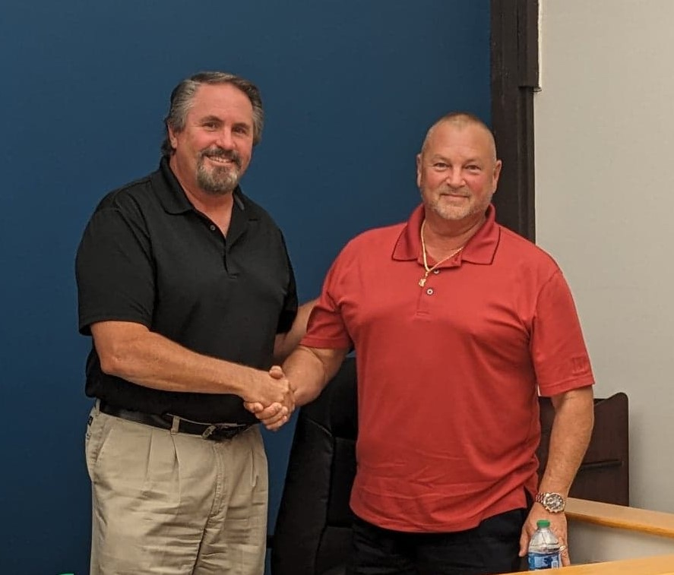On Monday, September 12th, the Village of Maybrook Board of Trustees approved the appointment of Charlie Woznick to replace Village Trustee Robert Pritchard who retired on August 22, 2022. Pritchard’s term expires in April of 2024 however an election will be held for the one year remaining on the term in March 2023. The Village Board also appointed Village Trustee James Barnett as Deputy Mayor to replace the former Deputy Mayor Robert Pritchard. Former Village of Maybrook Deputy Mayor and Village Trustee has been appointed to the Planning Board to replace Planning Board Member Charlie Woznick. Congratulations Trustee Charlie Woznick, Deputy Mayor James Barnett and Planning Board Member Noreen Reynolds!
- PETITION TO AMEND ZONING ORDINANCE- KNOLLWOOD DEVELOPMENT- Mr. Joe Betro advised he is here to amend the zone from R-5 to B-2. Mayor asked what type of business. Mr. Betro advised on a flex building, 1500 -2000 sq. ft. and residential on top. It would be retail, 3 separate buildings and ½ commercial spaces in each one. ( Flex warehouse in back), small retail. Mr. Betro advised of the impacts of the wetlands, housing doesn’t work. Mayor advised Conklin Lane residents had issues back then. Board advised they see them coming in with concerns. Attorney advised the Board they have received the request, it’s up to the Board if they wish to proceed. Trustee Greany & Trustee Capozzoli advised they want to see the building sizes, plan, and all. Attorney advised the Board should refer to their Planner and ask for additional information and plans. Engineer advised the applicant has been actively pursuing the application, he has been waiting on DOT. Mr. Betro advised he will reach out to Jay Samuelson and make sure it’s in with Conklin Lane. Mayor advised to be clear, we will look at it with our Planner. Engineer advised the applicant will keep his present approval, until he gets the zone change, then that would take precedent. He will not have both approvals at the same time.
- DON BERGER- TRI-MONTGOMERY UPDATE- Don, Randi & Liz advised the Board of the route, times, and place of events for the 10/15 Triathlon, which will go down Route 208 to Schipps Lane to the park, to Volunteer Place, to Clark Place to Neelytown Road. Wallkill Valley Federal Savings & Loan will have water in the park. Randi advised they want to make sure the Village Police Department is overseeing as the runners come through the Village, there will be a safety meeting on 10/4 at Benedict Park at 5:30PM. Chief Amthor advised he has assigned Officer Hughes and he will make sure he is there. The event is to highlight the parks, Friday night there will be a Spaghetti Dinner, there will be a Community Event on Sunday, free activities for the children and a Pancake Breakfast. There will be music from 12-5, and they expect about 200 runners.
- LETTER TO NYS DOT FROM MAYOR LEAHY, RE: NYS ROUTE 208 SIDEWALK DAMAGE- Mayor gave brief history on trying to fix sidewalks with grant money and therefore has put the NYS DOT on notice of the poor and dangerous sidewalks in the village and they can fix them. Mayor has sent Senator Skoufis a copy as well as the Governor, he has heard back from Senator Skoufis. Rec. & filed.
- AUTHORIZATION, PURCHASE OF REPLACEMENT PUMP & DISC FILTERS(STP)- Engineer advised on the disc filters, 20 for $3,278.20. Engineer has the quote and will forward to the Board. Matt advised the money is in the budget for it. Motion by Trustee Barnett, seconded by Trustee Capozzoli, authorizing the purchase of 20 disc filters for $3,278.20. 5 ayes, 0 nays. Matt advised on the Replacement Pump, $8,700 to repair and $10,000 for a new one. Board discussed options and better to purchase 2 new pumps, if we have money left in the budget at the end of the year. Attorney asked if this is a sole source item, Matt advised yes. Attorney advised Matt will need to write something for Tina for audit purposes to attach to purchase order, since we don’t need three quotes because it is a sole source item/purchase. Motion by Trustee Capozzoli, seconded by Trustee Greany, authorizing the purchase of a new Replacement Pump, not to exceed, $11,000. 5 ayes, 0 nays. Trustee Capozzoli asked to please note: to look to purchase one more new replacement pump at the end of the year.
- SPEED HUMPS REVIEW/UPDATE, ENGINEER SEAN HOFFMAN- Engineer advised of the draft report from John Canning for Clark Place, he recommends adopting a speed policy, to evaluate putting this in on Clark Place. He also recommends two (2) temporary rubber speed bumps. This will allow to put in different areas to see if it’s needed in another area. Matt advised and he will be putting the LED lighting around the STOP sign.
- AUTHORIZATION, POLICE VEHICLE PURCHASE- Chief advised we are purchasing the vehicles, a 2022 black Ford Interceptor, with the funds received from the two Ford Fusions that went back to Ford, the total for the car, delivery and equipment is $49,349.88, for 5 years, for the entire car, no lettering. The lettering will run a couple hundred dollars. Motion by Trustee Barnett, seconded by Trustee Greany for the purchase of police vehicle as quoted, for $49,349.88. 5 ayes, 0 nays. Chief advised Officer Erps did a fine job on getting the cars all straightened out and for the purchase of this vehicle. Board advised John Erps, nice job!
- AUTHORIZATION, DESTRUCTION OF RECORDS, RE: RECORDS MANAGEMENT- Trustee Barnett thanked Tina, Kyle, and Adam for the hard work they did with loads of boxes on Friday, a lot of hard work, Kyle and Adam are two excellent workers. Tina advised they were wonderful, she could not have done it without them and thanks them! Motion by Trustee Barnett, seconded by Trustee Greany, approving the records destroyed for records management. 5 ayes, 0 nays. (see attached)
- AUTHORIZATION, RETAINER AGREEMENT BETWEEN MAYBROOK, NY AND NAPOLI SHKOLINK PLLC- Attorney advised on Class Action which has taken so long, and feels the Board should participate. Motion by Trustee Barnett, seconded by Trustee Greany, to enter final retainer agreement for PFAs Class Action as a member. 5 ayes, 0 nays. Attorney advised and if they win, the village gets money.
MAYOR’S REPORT
- Family Movie Night- Just a reminder! The Village of Maybrook Family Movie Night that was rescheduled from July will be held on Friday, September 16th. The featured movie will be Disney’s “Luca”.
- Women’s Rec Softball- Our Maybrook Women’s Recreation Softball season has been extended through to September 29th. It has been a hot season and the extended forecast looks like more seasonably cooler weather coming in.
- Recreation Volley Ball- the Maybrook Recreation Co-ed Beach Volleyball programs wraps up their season this week. I’d like to thank Martin Brown (Thursday Nights) and Trisha Amthor (Tuesday nights) for coordinating a great season for those who participated!
- Montgomery Business Council “Tri-Montgomery Triathlon”- The Town of Montgomery Business Council will be hosting a triathlon in the Town of Montgomery on Saturday, October 15, 2022. The triathlon is being called the “Tri-Montgomery” since it will go through the three villages and the town. The race includes a 5.8 mile run, 17 mile bike ride and a 1 mile kayak. Registration ends on October 7th. For more information, visit the website at www.threevillages.org/tri-montgomery/
- Celebrate Maybrook Day 2022! -On Saturday, September 24th the Village of Maybrook will be hosting Celebrate Maybrook 2022 from 6:30 pm to 9:30 pm. This event will be held in the Frederick Myers Veterans Memorial Park. We will have amusement rides, Live music performed by “Hudson Blue”, Food, beer and wine and fireworks to end the evening! The amusement rides will be in the park on Thursday, Friday and Saturday 9/22, 23 & 24. Bracelets will be available all three nights. The cost is $35 per night.
- Maybrook Police Department “Bike Rodeo”- the Village of Maybrook Police Department will be sponsoring “Kid’s Bike Rodeo” on Saturday, September 24th in the Frederick Myers Veterans Memorial Park from 4:30 pm to 6:30 pm. This event is free to all residents. The event will include a bike rodeo obstacle course, bike registration, injury prevention tips, raffle prizes, an obstacle course bounce house and music provided by E-Rock Entertainment. This event is on the same day as Celebrate Maybrook Day which will take place 2 hours prior.
- Maybrook’s “Autumn Community Wide Yard Sale- The Village of Maybrook “Autumn Community Wide Yard Sale” will take place on Saturday, October 1st from 8 am to 3 pm. All residents are welcome to participate!
- Cancer Awareness– Also a reminder, the Village Board unanimously approved the Month of September for Ovarian Cancer Awareness, October for Breast Cancer Awareness and November for Pancreatic Cancer Awareness. Teal Ribbons will be displayed for Ovarian Cancer Awareness in September. Residents are welcome to participate.
- Letter to the Orange County IDA- I signed onto the following letter which has been endorsed by several elected officials from cities, towns and villages.
- Dear Orange County IDA Board:
While we appreciate the mission of economic development and, when appropriate, incentives, it is paramount that Orange County’s villages, towns, cities, and school districts have a formal role in the decision-making process when considering property tax abatements. The Orange County IDA makes
decisions that can have a significant impact on our tax base, revenue, and budgets yet we are completely relegated to the sidelines: we have no vote, no role in negotiations, and are left to simply write a letter or share comments at a public hearing that can and oftentimes are disregarded.
We are elected officials who have been entrusted at the ballot box to do right by our taxpayers; furthermore, we are the ones who must deal with the budget ramifications of the IDA’s decisions. As such, it is high time we receive a seat at the table. Moving forward, we insist on being treated the same way as the Rockland County IDA collaborates with its municipalities and school districts. The Rockland County IDA votes on whether to authorize “up to” a certain PILOT then leaves it to the taxing jurisdictions to negotiate the tax break – or refuse a PILOT. This cooperative approach has not stymied economic development in Rockland County all the while ensuring local leaders have a direct say in what is happening in their community.
In order for the Orange County IDA to maintain the confidence of its local leaders, it must adopt the same approach as is employed in Rockland. We and the taxpayers we represent deserve a formal seat at the table.
The tax breaks are out of control especially with the mega warehouses that have popped up over the last two years. The communities within the County should have a say over who receives tax breaks especially when it affects the residential tax base of working class people and seniors. I’m looking forward to the response of this letter.
- Next Village Board Meeting- Our next Village Board Meeting is scheduled for Monday, September 26th at 7 pm and will be held here, at the Village of Maybrook Government Center. In September, we will return to 2 meetings a month.

TRUSTEES’ REPORTS

TRUSTEE KEVIN GREANY- Advised the sewage treatment plant is going well, Donnie is catching up with paperwork and still working half days.
Welcome Charlie!

DEPUTY MAYOR JAMES R BARNETT- Welcome Charlie!
Advised Matt to please thank the guys, Kyle & Adam.
Advised Chief Amthor the guys did at great job in the Village of Montgomery General Montgomery Day, they represented the village well.
Showed trophy the band won on General Montgomery Day for best band, it was a lot of fun and made the village proud.
Advised on Wednesday night, Patricia Touhy, Tristan Brahm, and Brian Tompkins will become Eagle Scouts! Makes 85!
Advised our Engineer’s son has just had his Eagle Scout project approved and his younger son will have his Bar Mitzvah.
Wished all of our friends of the Jewish faith a very Happy New Year- Rosh Hashanah.
Advised he is honored to be selected for his remaining time on the Board as Deputy Mayor and will try to serve his very best. He is very proud and fortunate to serve for 45 years in different capacities, he’s honored and appreciates it more than you know.

TRUSTEE DARYL CAPOZZOLI- Advised the Community Center is going well, advised on the numbers and activity, he will have the numbers monthly now that we meet twice a month.
Congratulations Charlie!
Advised the guys are doing a good job, always working.
Advised Chief and Officer John Erps nice job on car.
Congratulations Jim!

TRUSTEE CHARLES D WOZNICK- Thanked Mayor for the appointment, he is honored and looks forward to the future and working with this Board, he’s honored!
Board all welcomed Charlie!

DEPARTMENT HEADS

POLICE CHIEF ARNOLD AMTHOR- Apologized for not adding to the agenda, but if the Board could consider removing Officer Ricky Maldonaldo from Probationary Status. Motion by Trustee Barnett, seconded by Trustee Greany, approving the removal of probationary status for P/T Officer Ricky Maldonaldo, effective immediately. 5 ayes, 0 nays. Deputy Mayor Barnett advised he has done an outstanding job!
Advised on the offer from the Fire Department for the Chief’s car sitting there, will enter an agreement with the Village to purchase for $5,000, real good addition for the department, already has the lighting package and rack. Matt advised we just need an inter-municipal sale agreement with our Village Attorney and the Fire District Attorney. Motion by Trustee Capozzoli, seconded by Trustee Woznick, to approve once agreement is in Attorney’s hands. 5 ayes, 0 nays.

DPW SUPERINTENDENT MATTHEW THORP- Advised they will be fiber-matting next Wednesday, following week will be paving, curbing is going well, couple of storm sewer issues.

ENGINEER SEAN HOFFMAN- Advised on Tower Avenue, they are doing a great job, we are finding basins and DPW is fixing them quickly.
Advised he did the grant on Friday and another NY Reform grant, we did not have the Public Hearing because the Grant Writer realized we really wouldn’t get and qualify for that one.

ATTORNEY KELLY NAUGHTON- Congratulations Jim & Charlie!

Motion by Trustee Barnett, seconded by Trustee Capozzoli, meeting was adjourned at 8:45PM. 5 ayes, 0 nays.

Respectfully submitted,

Valentina Johnson
Village Clerk-Treasurer

