Village of Maybrook

Board of Trustees Meeting

Agenda 01-24-22

7PM

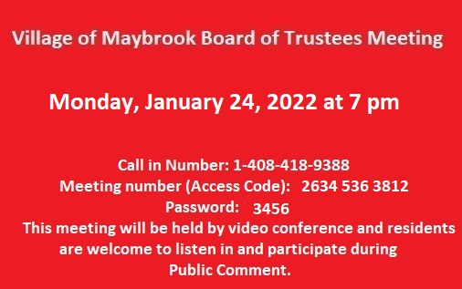

1. Introductory Local Law #1 of 2022, Amending Chapter 81 (“Buildings, Unsafe”)Of The Code Of The Village Of Maybrook To Expand The Chapter To Include Unsafe Structures And Trees.
2. Resolution, To Appoint Election Inspectors From the Orange County Board of Elections List From The Town of Montgomery & Town of Hamptonburgh.
3. Authorization, General Election Registration Notice.