Village of Maybrook
Board of Trustees Meeting
Agenda 01-10-22
7PM
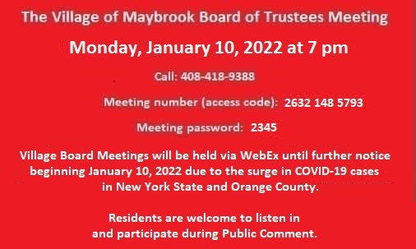

****7PM: Public Hearing, Introductory Local Law #7 of 2021, A Local law Enacting A New Provision Of Chapter 189 (“Vehicles And Traffic”) Of The Code Of The Village Of Maybrook To Restrict Parking Along Main Street
2. Town of Montgomery Supervisor Brian Mahar- Ambulance Corps.
3. Liberty Towers- Victoria Brennan- Wireless Antenna Opportunity
4. Letter Of Resignation, Maria Torres
5. Building Inspector’s Report, December 2021.
6. Thank you, Bill Schimpf
7. Thank you, Michael & Lauren Maresca & Family
8. Thank you, Linda Larosa
9. Thank you, Kevin & Lori Greany
10. Authorization, Removal of Probationary Status For F/T Police Officer John Erps.

