Village of Maybrook
Board of Trustees (SPECIAL MEETING)
Monday, December 20, 2021 at 6 :30 pm
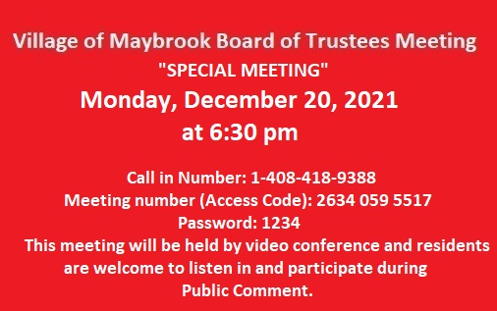

1. Authorization for payment for Community Development FY19 & FY20- NWMCC
2. Adoption of “No Smoking” Local Law.

