VILLAGE OF MAYBROOK
BOARD OF TRUSTEES MEETING
AGENDA 04-12-2021
REORGANIZATION MEETING
7PM

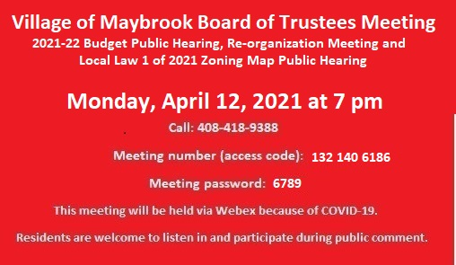
- BUDGET HEARING- 7PM
- SET PUBLIC HEARING FOR LOCAL LAW #2 OF 2021 OVERRIDING THE TAX LEVY LIMIT ESTABLISHED IN GENERAL MUNICIPAL LAW SECTION 3-c
- PUBLIC HEARING ON INTRODUCTORY LOCAL LAW # 1 OF 2021 AMENDING THE ZONING MAP OF THE VILLAGE OF MAYBROOK
- REORGANIZATION APPOINTMENTS/CONFIRMATIONS
- LETTER OF RESIGNATION, DPW LABORER WILLIAM DUNN
- BUSINESS COUNCIL OF GREATER MONTGOMERY MEMBERSHIP
- SET PUBLIC HEARING FOR CDBG FY-22

