Village of Maybrook

Board of Trustees Meeting

Agenda 03-08-2021

7PM

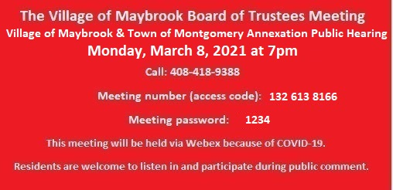

\*\*\* Public Hearing – Joint Hearing with the Town of Montgomery Annexation For Galaxy Property\*\*\*

1. Building Inspector’s Report, February 2021.
2. Draft Public Employer Health Emergency Preparedness Plan.
3. Authorization, STOP DWI contract for March 1, 2021-January 1, 2022.