Village of Maybrook

Board of Trustees Meeting

Agenda 01-25-2021

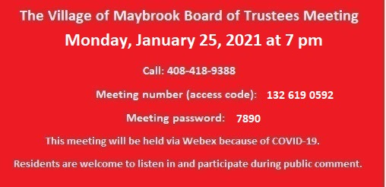

1. Town Supervisor Brian Mahar- Ambulance District
2. Galaxy- Review/adoption of the Negative Declaration, & Set Joint Public Hearing with the TOM on annexation petition.
3. Building Report- December, 2020.
4. Letter of Resignation & Reinstatement (For Retirement Purposes)- Police officer Peter Frederick
5. Refuse Contract Discussion.