Village of Maybrook
Board of Trustees Reorganization Meeting
7PM

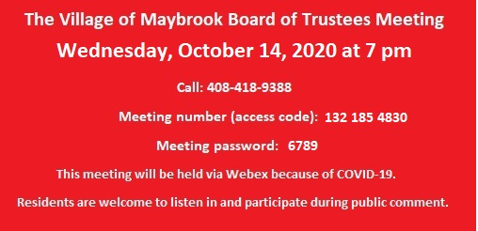
****Public Hearing- 7PM- Local Law #4 of 2020, Amending Chapter 210 ( “ Zoning”) of the Code of the Village of Maybrook To Permit Business Parks In The I-3 District
****Public Hearing- Local Law #5 of 2020, Amending The Zoning Map Of The Village of Maybrook.
****REORGANIZATION ****
CORRESPONDENCE
- Authorization, IEC (Independent Electrical Contractors) New York: Approving to be added to list of approved agencies.
- Authorization, Local Emergency Order- Halloween

